Ahsanullah University of Science and Technology
Department of Computer Science and Engineering



Experiment No 1

Designing a Minimum Distance to Class Mean Classifier

Pattern Recognition Lab
CSE – 4214

Submitted By
Tahjib Hassan Rhythm
ID: 14.01.04.070

Designing a Minimum Distance to Class Mean Classifier

Tahjib Hassan Rhythm
Department of Computer Science and Engineering
Ahsanullah University of Science and Technology
Dhaka, Bangladesh.

Objective
The main objective of this assignment is to see the effect of designing a minimum distance classifier with MATLAB scripting and find out the basics of pattern recognition.

Introduction
Class Mean Classifier is used to classify unclassified sample vectors where the vectors are classified in more than one class. For example, in our dataset we have some sample vectors. Some given sample vectors are already classified into different classes and some are not classified. We can classify the unclassified sample vectors by the help of Minimum Distance to Class Mean Classifier.

Tasks
- Plot all sample points from both class datasets (w, w1), but samples from the same class should have the same color and marker.
- Using a minimum distance classifier with respect to ‘class mean’, classify the testing dataset points with the help of Linear Discriminant Function:
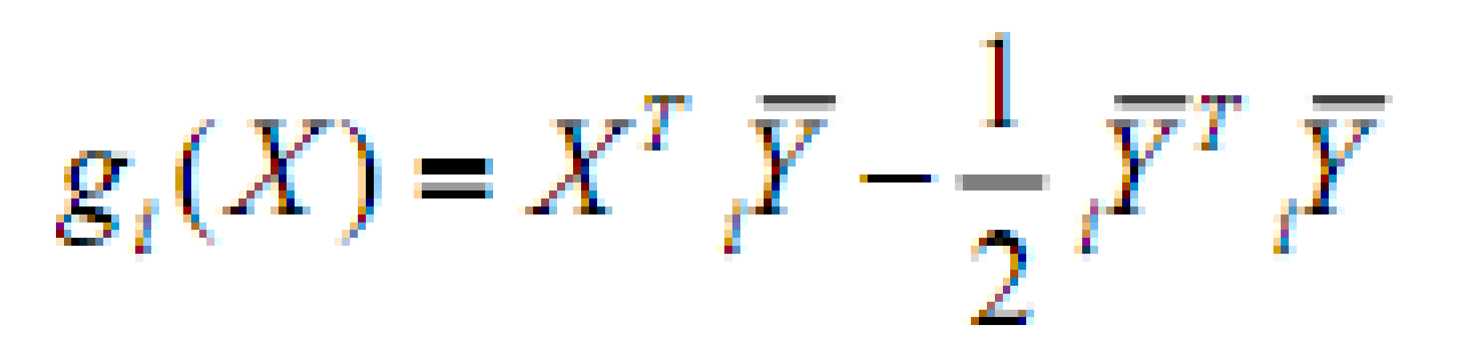
- Draw the decision boundary between the two-classes.

Implementation
- First Step (Plot the training datasets) :
At first we have to plot all the sample points of both classes. Samples from the same class are plotted using the same color and marker. So that different classes can be distinguished easily. Here red stars ‘*’ represent class w and green stars ‘+’ represent class w1.

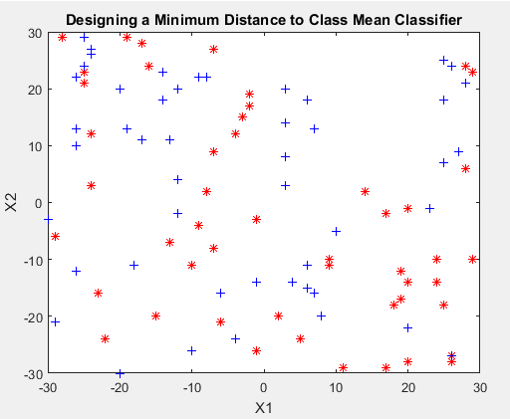

Figure 1: Plotting 50 sample points for two classes

- Second Step (Classify the following points):
The mean points of the two classes are calculated & plotted with same class color with the ‘O’ marker (‘O’ for class w1 & ‘O’ for class w2).
Now for each of the points we can calculate the distance from the calculate mean of each class using Linear Discriminant Function.
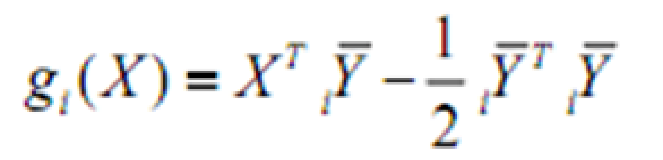

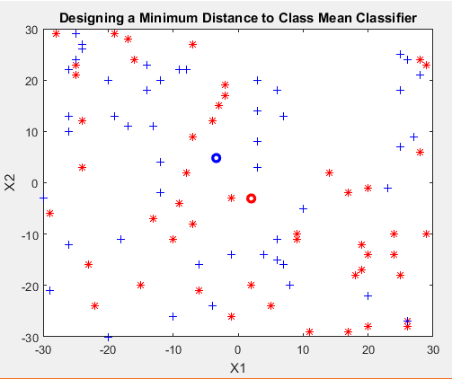

Figure 2: Mean values of class w and class w1

Here red star ‘*’ to represent class w and blue plus‘+’ represent class w1 and red ‘O’ represents mean value of class w and blue O ‘O’ represents mean value for class w1.

- Third Step (Drawing the decision boundary)
In the last step, we will draw the decision boundary. For finding out the decision boundary we will consider all possible points within the range. We will consider those points as over the boundary line whose distance from both the classes are same. Here ‘-’ line creates with brown color represents the linear decision boundary between the two classes.

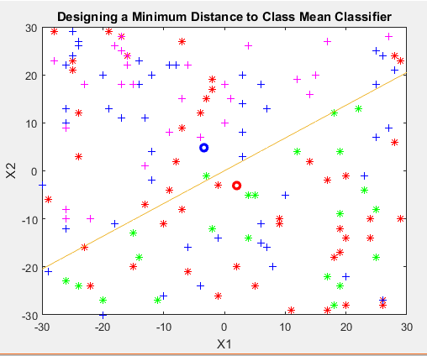

Figure 3: Drawing the decision boundary

MATLAB Code
%Taking sample input and plotting
W=xlsread('50w.xls');
W1=xlsread('50w1.xls')

plot(W(:,1),W(:,2),'r*')
hold on
plot(W1(:,1),W1(:,2),'b+')
hold on

%calculating the mean
m1=mean(W);
m2=mean(W1);
hold on

m3 = plot(m1(1),m1(2),'O','MarkerEdgeColor','r','LineWidth',2.5);
hold on

m4 = plot(m2(1),m2(2),'O','MarkerEdgeColor','b','LineWidth',2.5);
hold on
%sapmle input

X=xlsread('50s1.xls');
%Calculating Linear Discriminant Function
for i = 1:length(X)
g1=X(i,:)*m1'-0.5*m1*m1';
g2=X(i,:)*m2'-0.5*m2*m2';
if(g1>g2)
plot(X(i,1),X(i,2),'g*');
hold on
else
plot(X(i,1),X(i,2),'m+ ');
hold on;
end
end

%Decision Boundary

coefficient = m1-m2;

constant = -0.5*det((m1' * m1)- (m2' * m2));

bon = [-30:1:30];

plot(decision_boundary(:,1),decision_boundary(:,2),'-.b');
hold off;

Result Analysis
We have taken three datasets for result analysis. One of them contains 10 sample values for both the classes and 10 values for testing. Second one has 50 samples values and the third one has 1000 values. For dataset 1, the testing result is show in figure 4.

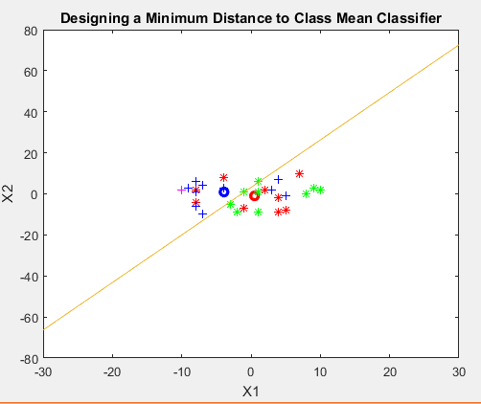

Figure 4: Testing result for 10 sample inputs

Now for dataset 2, Figure 5 shows the results.
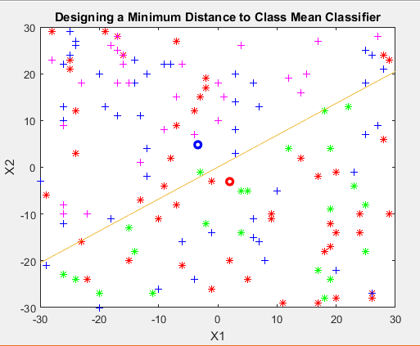

Figure 5: Testing result for 50 sample inputs

Now for dataset 3, Figure 6 shows the results.

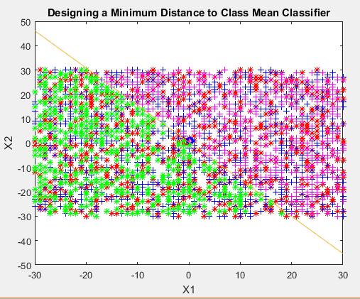

Figure 6: Testing result for 1000 sample inputs

Conclusion
The minimum distance to class mean classify is a simple classiﬁer uses very simple calculations which is very easy to implement. However the misclassiﬁcation rate of this classiﬁer is relatively higher since the decision boundary is linear.

